Frequency encoded computational spectral sensing
Yijia Zeng¹, Tingbiao Guo^{1,}*, Sailing He^{1,}*
1 Centre for Optical and Electromagnetic Research, National Engineering Research Center for Optical Instruments, College of Optical Science and Engineering, Zhejiang University, Hangzhou, Zhejiang, China
2 Department of Electromagnetic Engineering, School of Electrical Engineering, Royal Institute of Technology, Stockholm S-10044, Sweden
*Corresponding authors: sailing@kth.se and tbguo@zju.edu.cn

Abstract
High-fidelity spectroscopy in real-world environments is severely limited by unpredictable ambient interference and the inherent trade-off between acquisition speed and signal-to-noise ratio (SNR). Conventional time-division multiplexing (TDM) approaches often fail as they lack intrinsic mechanisms to decouple target signals from background illumination. Here, we propose orthogonal frequency encoding (OFE), a robust framework that shifts spectral acquisition from serial scanning to a parallelized frequency-domain architecture. By encoding each spectral channel with a distinct orthogonal frequency kernel, it strategically allocates carriers to spectral gaps to effectively evade structured environmental noise. As a proof of concept, we use a programmable LED array to demonstrate single-shot spectral reconstruction based on this framework. The system exhibits exceptional immunity to high-energy interference, maintaining high reconstruction fidelity (RMSE ≈ 0.0261) even under an extreme SNR of -11.77 dB. This work establishes a fast, low-cost paradigm for spectral sensing in challenging electromagnetic environments.
Introduction
Spectroscopic sensing stands as an essential technology across diverse disciplines, finding critical utility in precision agriculture, environmental monitoring, and clinical diagnostics. However, achieving high-fidelity spectroscopy in real-world environments remains a significant challenge, primarily due to unpredictable ambient interference. Conventional dispersive spectrometers based on gratings or prisms are not only compromised by bulky form factors and high costs but also inherently constrained by the need for narrow entrance slits, which severely limits optical throughput. More critically, these systems indiscriminately accumulate total photon flux due to a lack of intrinsic mechanisms to decouple the target signal from background illumination. This mixes the target signal with ambient interference, causing spectral reconstruction to fail in real-world scenarios.
Computational spectroscopy offers a promising pathway to overcome these physical limitations. However, existing paradigms remain constrained by an inherent trade-off between signal-to-noise ratio (SNR), acquisition speed, and spectral resolution. Snapshot approaches, such as filter arrays, achieve acquisition speed but inherently suffer from a spatial-spectral trade-off that limits their spectral resolution. Conversely, time-division multiplexing (TDM) approaches, ranging from tunable spectral filters to sequential active illumination, offer high spectral fidelity but rely on serial acquisition. This temporal sequentiality dictates that the total acquisition time scales linearly with the number of spectral channels ($T_{total}∝N$), rendering them ineffective for capturing transient dynamics. Ultimately, these computational frameworks remain strictly bound to controlled lighting environments due to their lack of an intrinsic encoding mechanism to effectively decouple the active signal from ambient interference.
In this work, we propose a robust framework for spectral sensing in challenging environments, termed orthogonal frequency encoding (OFE). Unlike standard lock-in detection or post-detection unmixing strategies, this scheme ensures rigorous isolation by encoding each spectral basis function via a distinct orthogonal frequency kernel, enabling the simultaneous reconstruction of all encoded spectral channels via a single-pixel detector in a single-shot acquisition. We employ a low-cost, programmable LED array as a demonstration of this framework. The results demonstrate that this strategy enables accurate spectral reconstruction even under a SNR as low as -11.77 dB, a regime where conventional approaches fail. Furthermore, it achieves ultrafast sensing with acquisition times as short as 250 μs. This work establishes a robust, fast and low-cost framework for spectral sensing in challenging environments.
Principle
Under the TDM architecture, spectral channels are activated sequentially according to a predefined timing sequence. The instantaneous intensity $y_{\text{TDM}}\left(t\right)$ received by the detector at any given time $t$ represents the superposition of the spectral signal from the single channel within the current time slot and the ambient noise:
 | $$y_{\text{TDM}}\left(t\right)=\int_{λ_{1}}^{λ_{2}}{\sum_{k=1}^{K}{\left[P_{k}\left(λ\right)⋅\text{rect}\left(\frac{t-kτ}{τ}\right)\right]}}⋅R\left(λ\right)S\left(λ\right)dλ+I_{\text{noise}}\left(t\right)$$ | (1)
where $P_{k}\left(λ\right)$ denotes the spectral basis function of the $k$-th channel for the spectral sensing system. $\text{rect}\left(⋅\right)$ represents the unit rectangular function, acting as a temporal gating operator that characterizes the serial scanning mechanism, where the $k$-th channel is active solely during its specific integration time $τ$. $R\left(λ\right)$ represents the reflectance or transmittance spectrum of the target, $S\left(λ\right)$ denotes the detector's spectral responsivity, encompassing both photoelectric conversion efficiency and transimpedance gain. And $I_{\text{noise}}\left(t\right)$ denotes the ambient light noise.
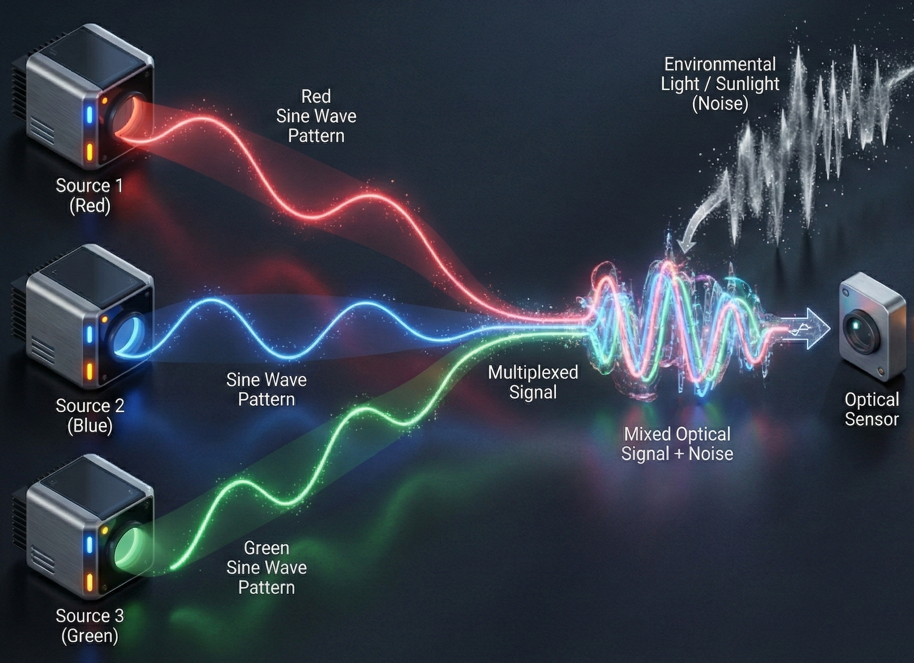
Figure 1. OFE schematic diagram.

In orthogonal frequency encoding scheme, we substitute the binary temporal gating operator $\text{rect}\left(⋅\right)$ with a modulation kernel $m_{k}\left(t;f_{k}\right)$ uniquely assigned to that channel. This substitution eliminates the requirement for sequential time slots, allowing all channels to operate in parallel. The modulation kernel for the $k$-th channel is formulated as:
 | $$m_{k}\left(t;f_{k}\right)=a_{k,0}+a_{k,1}\cos\left(2πf_{k}t+φ_{k}\right)$$ | (2)
where $f_{k}$ is the distinct carrier frequency assigned to channel $k$. $a_{k,0}$ represents the DC bias required to ensure non-negative optical intensity. $a_{k,1}$ denotes the carrier amplitude, and $φ_{k}$ is the initial phase of the signal.
Upon simultaneous projection of all spectral channels modulated by their respective kernels, the detector integrates the total photon flux. The received OFE signal $y_{\text{OFE}}\left(t\right)$ is a composite waveform containing information from all$K$channels concurrently:
 | $$y_{\text{OFE}}\left(t\right)=\sum_{k=1}^{K}{\underset{z_{k}}{\underbrace{\left[\int_{λ_{1}}^{λ_{2}}{P_{k}\left(λ\right)R\left(λ\right)S\left(λ\right)dλ} \right]}}}⋅m_{k}\left(t;f_{k}\right)+I_{\text{noise}}\left(t\right)$$ | (3)
To simplify the physical interpretation, we define the scalar $z_{k}$ as the spectral projection value for the $k$-th channel. Substituting the modulation kernel into equation (3), the received signal $y_{\text{OFE}}\left(t\right)$ can be reorganized into two distinct components:
 | $$y_{\text{OFE}}\left(t\right)=\underset{\text{DC }\text{\&} \text{Noise component}}{\underbrace{\sum_{k=1}^{K}{z_{k}a_{k,0}}+I_{\text{noise}}\left(t\right)}}+\underset{\text{Signal }\text{c}\text{omponent}}{\underbrace{\sum_{k=1}^{K}{z_{k}a_{k,1}}\cos\left(2πf_{k}t+φ_{k}\right)}}$$ | (4)
The signal decomposition is achieved by mapping the time-domain observation into the frequency domain. Defining $F\{⋅\}$ as the continuous Fourier transform operator, the frequency-domain response $Y\left(f\right)$ is given by:
 | $$Y\left(f\right)=F\{I_{\text{noise}}\left(t\right)\}+\sum_{k=1}^{K}{\frac{1}{2}}z_{k}a_{k,1}\left[e^{jφ_{k}}δ\left(f-f_{k}\right)+e^{-jφ_{k}}δ\left(f+f_{k}\right)\right]$$ | (5)
where $δ\left(⋅\right)$ denotes the Dirac delta function. This formulation demonstrates the mechanism of noise rejection: as long as the modulation frequencies $\{f_{k}\}$ are designed to avoid the dominant bands of environmental noise and are mutually non-interfering, the projection value $z_{k}$ can be retrieved precisely by extracting the magnitudes at the corresponding carrier frequencies:
 | $$\left|Y\left(f_{k}\right)\right|=\frac{1}{2}z_{k}a_{k,1}⇒z_{k}=\frac{2\left|Y\left(f_{k}\right)\right|}{a_{k,1}}$$ | (6)
Once the projection values for all $K$ channels are retrieved, they are aggregated to form the measurement vector $z={\left[z_{1},z_{2},…,z_{K}\right]}^{T}$.To recover the spectrum $R\left(λ\right)$ of the target, we discretize the spectral range $\left[λ_{1},λ_{2}\right]$ into $N$ bands and model the measurement process as a system of linear equations:
 | $$z=Wr+e$$ | (7)
where $r∈R^{N}$ represents the ground truth (GT) spectrum, and $W∈R^{K×N}$ is the pre-calibrated system matrix determined by spectral sensing system. The term $e$ accounts for the system noise and measurement residuals. Consequently, the spectral reconstruction is treated as an inverse problem. The estimated spectrum $\hat{r}$ is obtained by finding the solution that minimizes the reconstruction error:
 | $$\hat{r}=\underset{r}{arg min}{{\left\|z-Wr\right\|}_{2}^{2}}$$ | (8)

